NAME: rana aldosari ID:20193017
B.1 Test the Staff class:
StaffTestCase1:
package test;

import static org.junit.Assert.*;
import org.junit.Test;
import model.Staff;

public class StaffTestCase1 {

Staff s= new Staff("Ali",8000,"Research","Research Assistant");

@Test
public void testCalcNetSalary() {
assertEquals(8800,s.calcNetSalary(),0);
}

@Test
public void testStaffSConstracutor() {
testGetJobTitle();
testGetName();
testGetSalary();
testGetUnitName();
}

@Test
public void testGetUnitName() {
assertEquals("Research",s.getUnitName());
}

@Test
public void testGetJobTitle() {
assertEquals("Research Assistant",s.getJobTitle());
}

@Test
public void testGetName() {
assertEquals("Ali",s.getName());
}

@Test
public void testGetSalary() {
assertEquals(8000,s.getSalary(),0);
}

}

StaffTestCase2:
package test;

import static org.junit.Assert.*;
import org.junit.Test;
import model.Staff;

public class StaffTestCase2 {

Staff s= new Staff();

@Test
public void testCalcNetSalary() {
assertEquals(0,s.calcNetSalary(),0);
}

@Test
public void testStaffStringDoubleStringString() {
testGetJobTitle();
testGetName();
testGetSalary();
testGetUnitName();
}

@Test
public void testGetUnitName() {
assertNull(s.getUnitName());
}

@Test
public void testGetJobTitle() {
assertNull(s.getJobTitle());
}

@Test
public void testGetName() {
assertNull(s.getName());
}

@Test
public void testGetSalary() {
assertEquals(0,s.getSalary(),0);
}

}

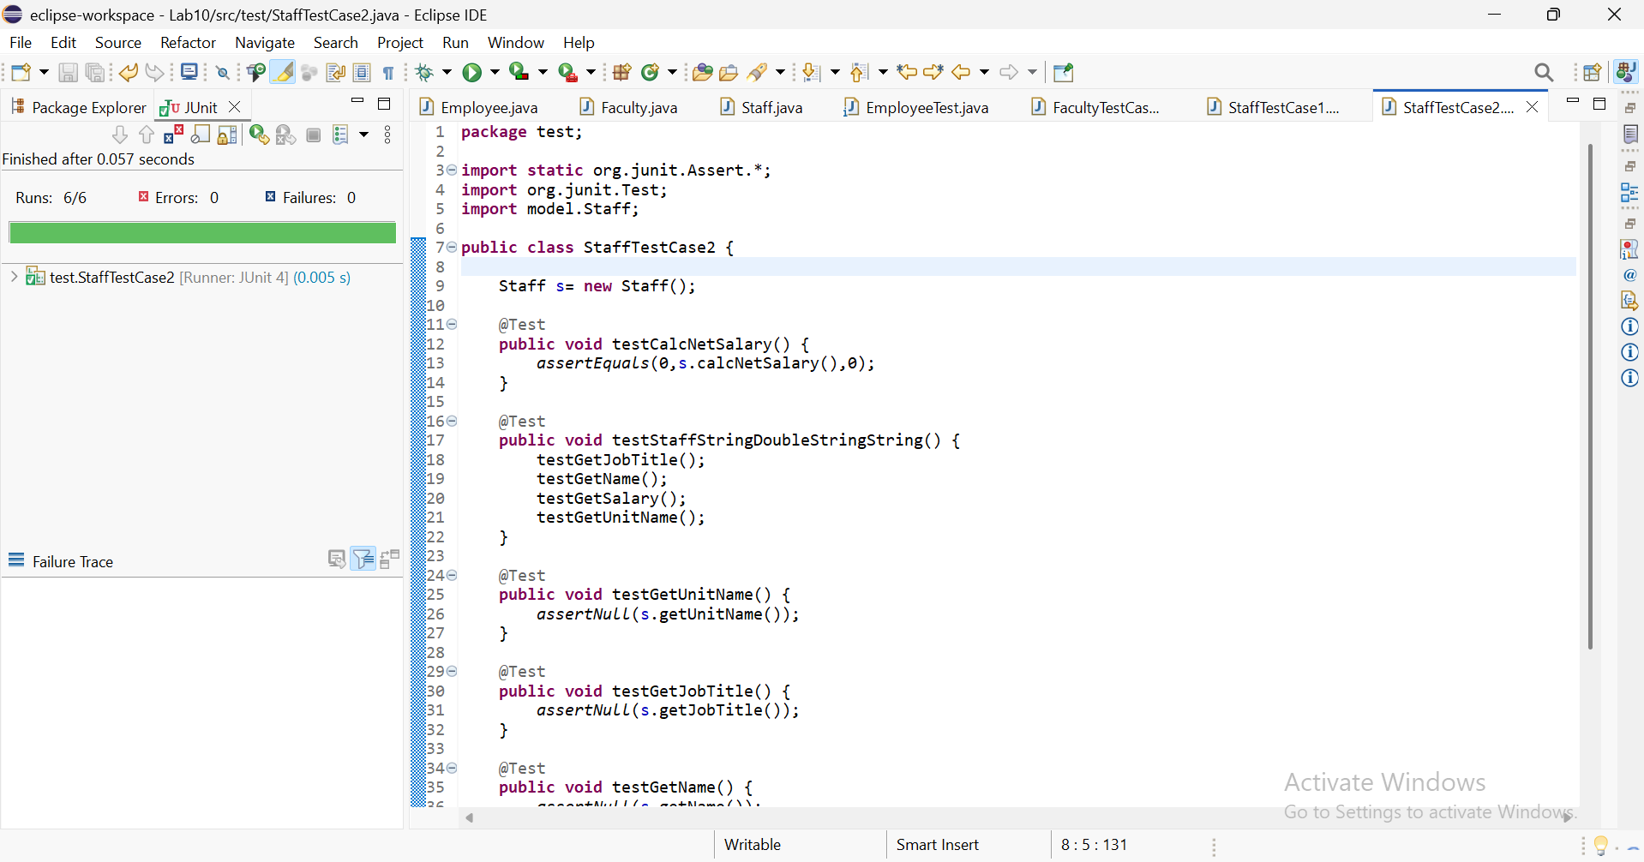

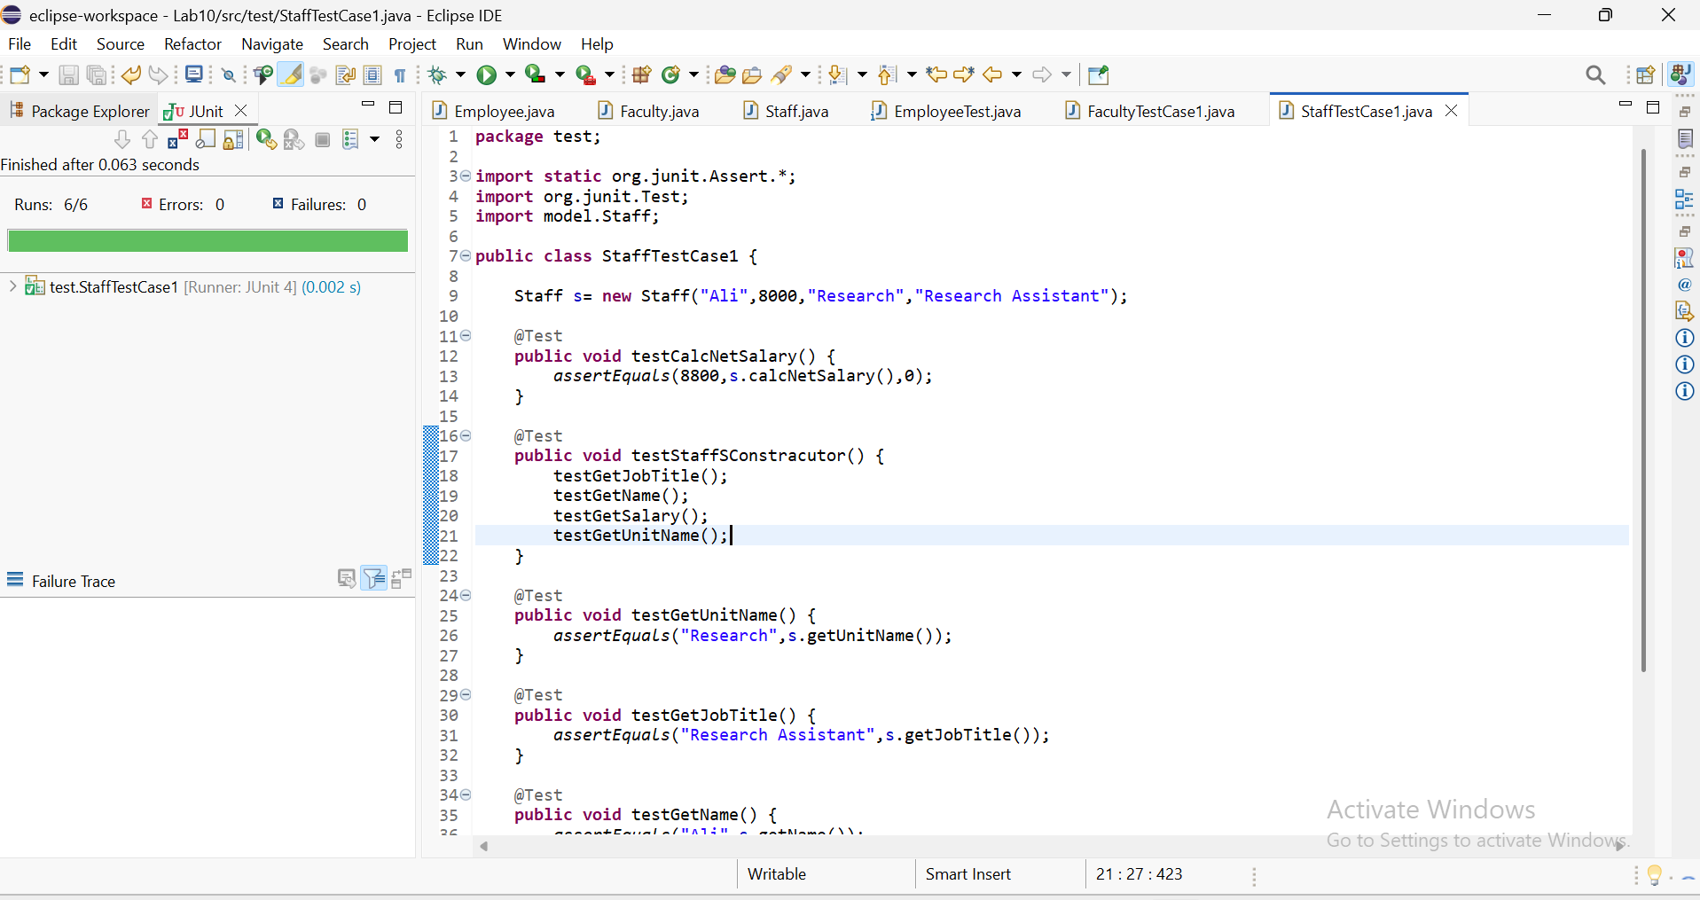

B.2 Find bugs with SpotBugs:
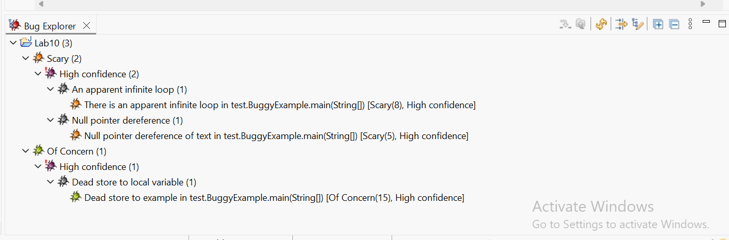
package test;

public class BuggyExample {

public static void main(String[] args) {
BuggyExample example = new BuggyExample();

// Example 1: Null pointer dereference
String text = "welcome";
System.out.println(text.length()); // SpotBugs should warn about a possible NPE

// Example 2: Infinite loop / suspicious code
int i = 0;
while (i < 10) {
System.out.println("Looping");
i++;
}
}
}
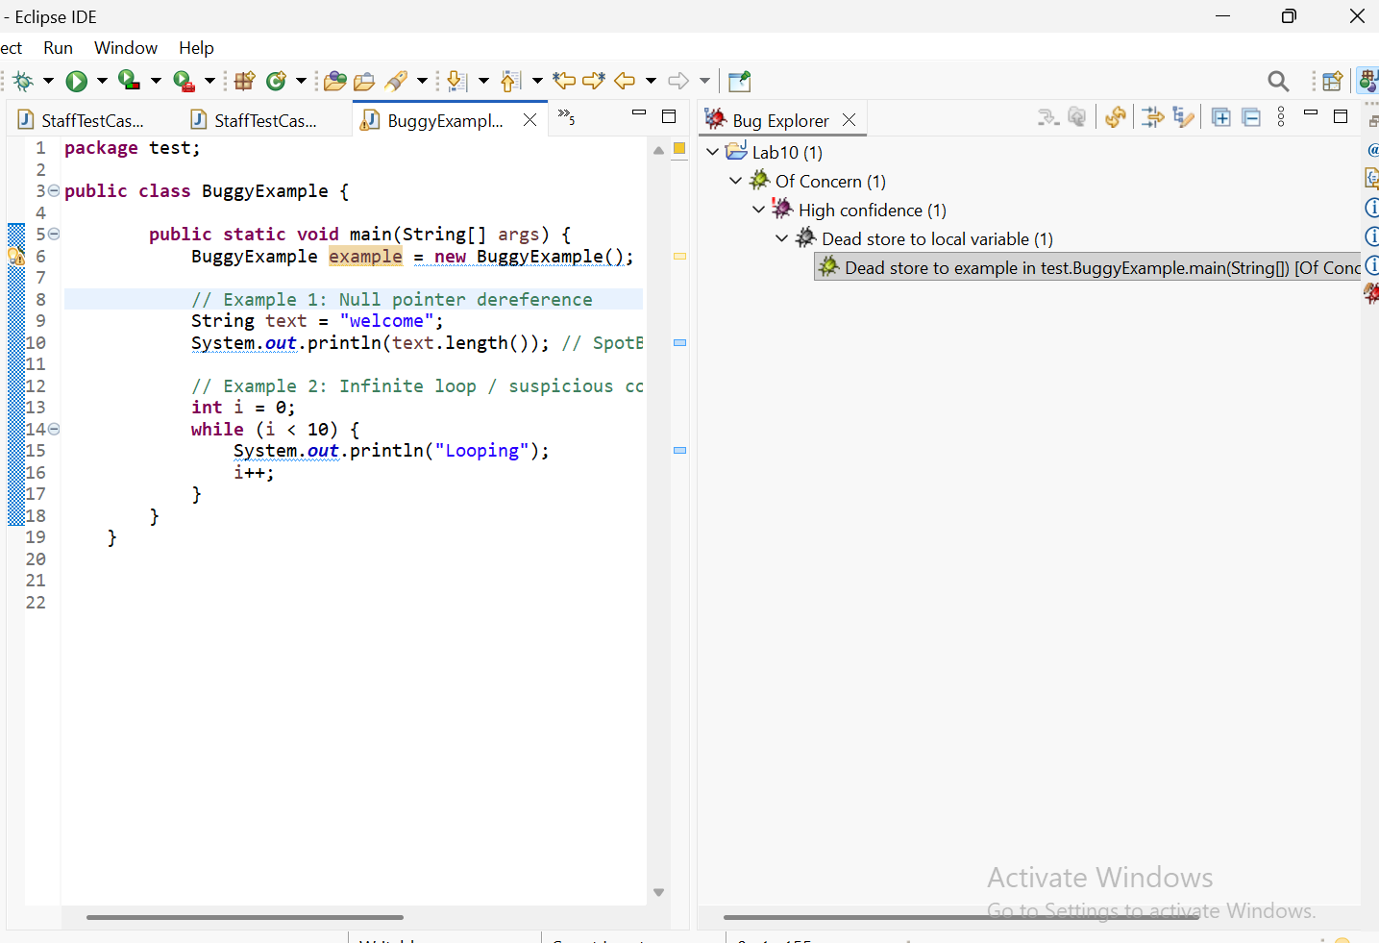
B.3 Find issues with SonarQube:
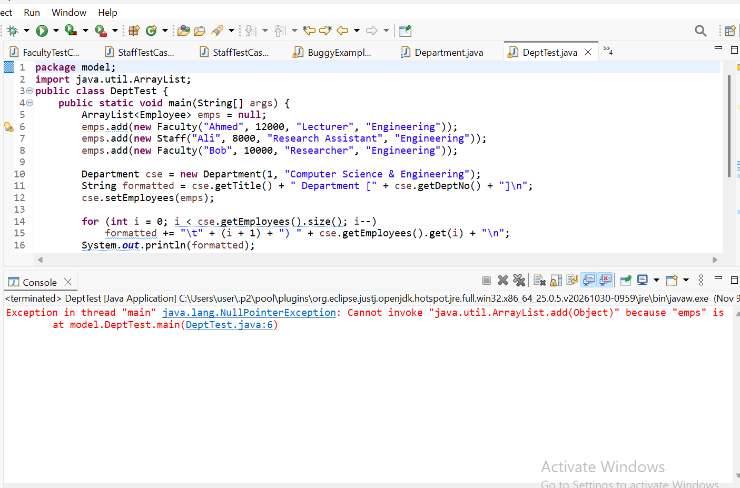
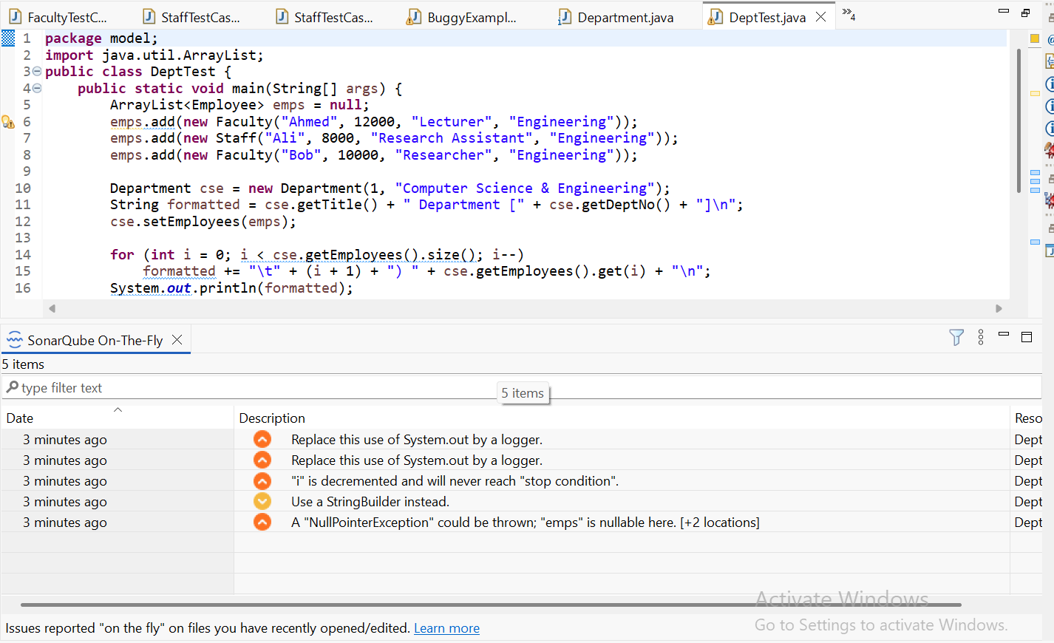
package model;
import java.util.logging.Logger;
import java.util.ArrayList;
public class DeptTest {
private static final Logger LOGGER=Logger.getLogger(DeptTest.class.getName());
public static void main(String[] args) {
ArrayList<Employee> emps = new ArrayList<>();
emps.add(new Faculty("Ahmed", 12000, "Lecturer", "Engineering"));
emps.add(new Staff("Ali", 8000, "Research Assistant", "Engineering"));
emps.add(new Faculty("Bob", 10000, "Researcher", "Engineering"));
Department cse = new Department(1, "Computer Science & Engineering");
StringBuilder formatted = new StringBuilder();
formatted.append(cse.getTitle()).append(" Department [").append(cse.getDeptNo()).append("]\n");
cse.setEmployees(emps);
for (int i = 0; i < cse.getEmployees().size(); i++)
formatted.append("\t").append(i + 1).append(") ").append(cse.getEmployees().get(i)).append("\n");
LOGGER.info(formatted.toString());
double sum = 0;
for (Employee e : cse.getEmployees())
sum += e.getSalary();
double avg = sum / cse.getEmployees().size();
LOGGER.info("Average Salary for CSE: }" + avg);
}

}



